**New CEMEX Go Poster - for your Noticeboards**

We have prepared a new poster (as shown here) to keep raising awareness of CEMEX Go and the go-live date of first week April. It summarises the benefits to our customers and our own people, and explains how customers can - Request orders; Track deliveries; Request changes to orders; Check invoices and Make Payments.

You can download it from [www.cemexuknews.co.uk](http://www.cemexuknews.co.uk) – then print locally on A3 or A4 and pin on your Notice Boards

**Launch Events Coming To You Soon in April**

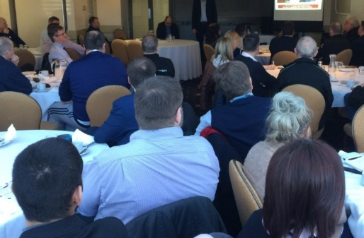CEMEX Go Launch Briefings will be held in April to support the ‘General Release’ of CEMEX Go to our customers in April. These will follow a ‘Launch Release’ which is currently planned to take place for 12 specific customers in w/c April 3rd just after Easter Monday. The one-hour briefings will include slides and video explanations followed by a short Q&A session. They will explain why we are investing in CEMEX Go, the roll-out plan and the change management process. Dates are now fixed for Rugby 12th April; Uddingston - 17th April; Stockton - 18th April; Preston Brook – 25th April. More information soon!

**Master Data Cleansing Complete!**

Sue Hawkins, Emma Robinson and the Deployment Team have done a brilliant job cleansing our customer master data which held many thousands of older and dormant accounts from previous years. The arrival of CEMEX Go is the perfect opportunity to remove lapsed customers and focus our digital efforts on recently active customers. Sue commented “It’s a bit like clearing out your loft or garage – always hard to get started but very satisfying to complete, knowing that we’re just keeping the most relevant and up to date information.”

**How we will target customers for CEMEX Go adoption**

When we go-live, it will be vital to attract customers not just to register for CEMEX Go, but also start using it day to day. In readymix we will target customers based on order bank data to increase usage & adoption. A detailed customer onboarding plan is being developed which will include face to face, telephone and virtual onboarding scenarios. As reported last week, our first two customers have already signed up for Cemex Go on bulk cement.